In [87]:
import cv2
import numpy as np
import matplotlib.pyplot as plt

In [109…
img = cv2.imread("1.jpeg", cv2.IMREAD_COLOR)

# Split the image into the B,G,R components
b, g, r = cv2.split(img)

# Show the channels
plt.figure(figsize = (20, 5)) #SIZE DIMENSIONS

# Red Channel
plt.subplot(1, 4, 1)
plt.imshow(r, cmap = "gray") plt.title("Red Channel")
plt.axis("off")

# Green Channel
plt.subplot(1, 4, 2)
plt.imshow(g, cmap = "gray") plt.title("Green Channel")
plt.axis("off")

# Blue Channel
plt.subplot(1, 4, 3)
plt.imshow(b, cmap = "gray") plt.title("Blue Channel")
plt.axis("off")

# Merge the individual channels into a BGR image
merged_img = cv2.merge((b, g, r))
rgb_img = cv2.cvtColor(merged_img, cv2.COLOR_BGR2RGB)

# Show the merged output
plt.subplot(1, 4, 4) plt.imshow(rgb_img)
plt.title("Merged Output") plt.axis("off")
plt.show()

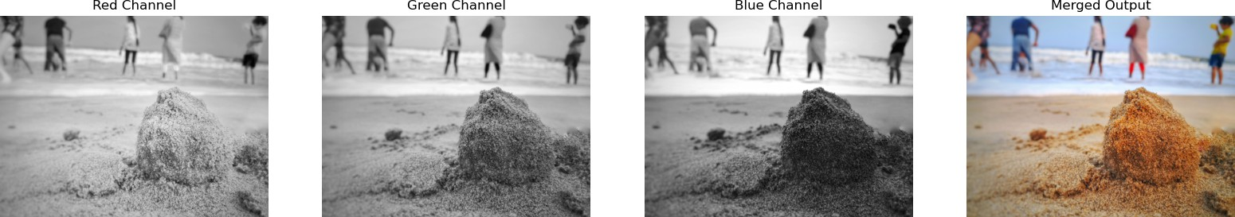

In [104…
#DEFAULT => BGR
#CONVERT => COLOR_BRG2--- [HSV, GRAY, RGB]
img_rgb = cv2.cvtColor(img, cv2.COLOR_BGR2HSV) img_rgb

Out[104… | array([[[103, | 49, | 83],
 | [103, | 49, | 83],
 | [103,  ..., [107, | 50,  57, | 82],  187],
 | [110, | 55, | 187],
 | [110, | 55, | 187]],
 | [[106, | 46, | 83],
 | [106, | 46, | 83],
 | [103,  ..., [108, | 49,  56, | 83],  187],
 | [110, | 55, | 187],
 | [110, | 54, | 188]],
 | [[106, | 34, | 83],
 | [111, | 40, | 83],
 | [106,  ..., [110, | 45,  55, | 85],  187],
 | [110, | 55, | 187],
 | [110, | 55, | 187]],

...,

[[ | 20, | 106, | 120],
[ | 20, | 106, | 120],
[ | 20, | 106, | 120],
...,
[ | 18, | 149, | 116],
[ | 18, | 151, | 115],
[ | 18, | 152, | 114]],
[[ | 20, | 106, | 120],
[ | 20, | 106, | 120],
[ | 20, | 106, | 120],
...,
[ | 18, | 152, | 114],
[ | 18, | 152, | 114],
[ | 18, | 153, | 113]],
[[ | 20, | 106, | 120],
[ | 20, | 107, | 119],
[ | 20, | 107, | 119],
...,
[ | 18, | 152, | 114],
[ | 18, | 152, | 114],
[ | 18, | 153, | 113]]], | dtype=uint8)

In [107…
print("Shape of the image: ", img_gray.shape)
print("Data type of the image: ", img_gray.dtype) print("Size of the image: ", img_gray.size)

Shape of the image: (3060, 4080) Data type of the image: uint8
Size of the image: 12484800

